Test Objectives

The objective of the test is to verify that the functionality of voice transformer works according to the specification. We are going to look for existing faults in our program and fix the errors.

Test plan

For Register Account function, we want to test whether the user login information are inserted to the database for our local server. We also want to know the Rong cloud server can connect with our local database with the token they generated.

Furthermore, we want to ensure user login information will be validated by using local database server. If user login failed, we will alert user will “Toast” function in java file, to ensure the validation works. And we will figure it out whether the Rong cloud database server can link to our local server for our further functionality.

Unit Testing

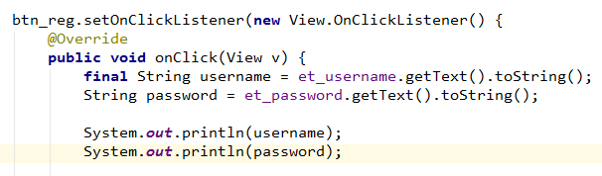

When we input the username and password and then click “submit” button, the onClick method should read the username and password from the textview and store in the params.  We use the “System.out.println” to show if it really can get the user input.

Output:

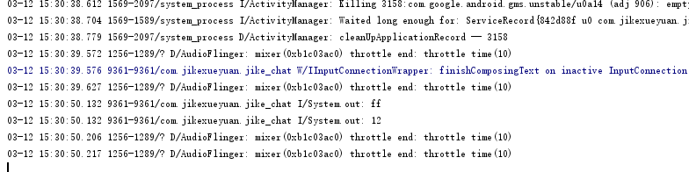

It turns out that the onClick method do get the username and password after the user click “submit” button.

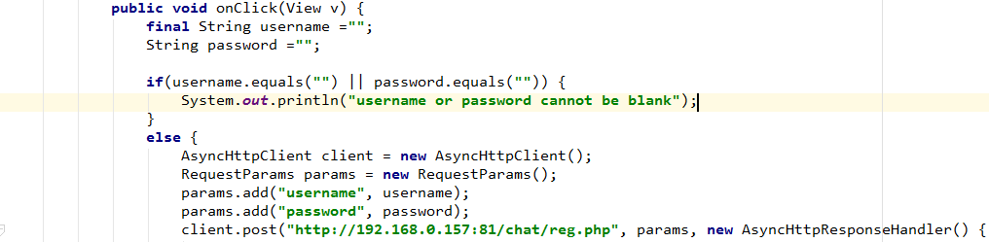

Only when the username and password are both filled out then will execute else statement. In order to test the if-else statement, we set the username and password to be blank respectively.

Output:

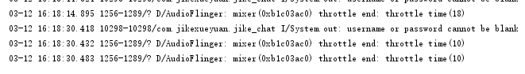

System prints out the username or password cannot be blank successfully. This means that the if condition will make sure the user input the valid username and password.

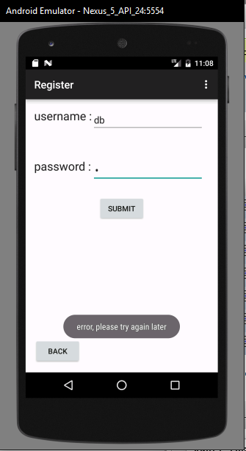

By using “client.post” to send a request to the local server. However, the post request is not be able to call the reg.php.

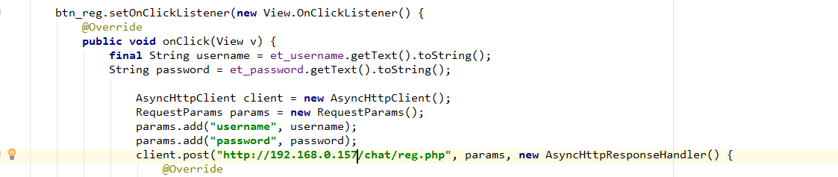

The debug message shows that the connection between the “client.post” and “reg.php” hasn’t set up correctly. Because HTTP address cannot link to the local “htdocs” file. The correct address is “http://192.168.0.157:81/reg.php”, the apache is using port: 81, therefore we cannot get into the “reg.php” without typing localhost:81.

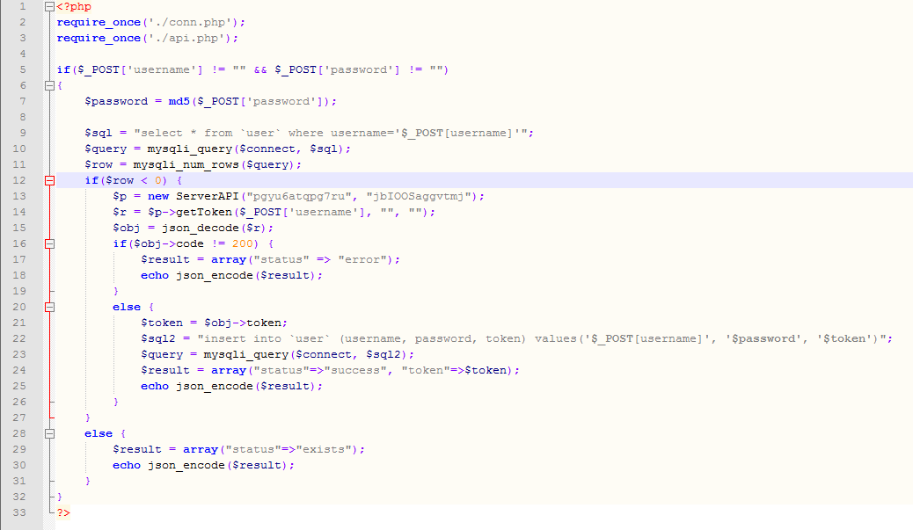Above is our “reg.php” file, in order to prevent same username we use a query to search on the database to find if there is a row has same username. And if the rows is more than 0, then system will pop up a response to the user that the username already exist. We set  if the row is smaller than 0 which makes it impossible for user to sign up. This is an algorithmic fault. After change it to “$row == 0”, the bugs has been fixed.

Integration Testing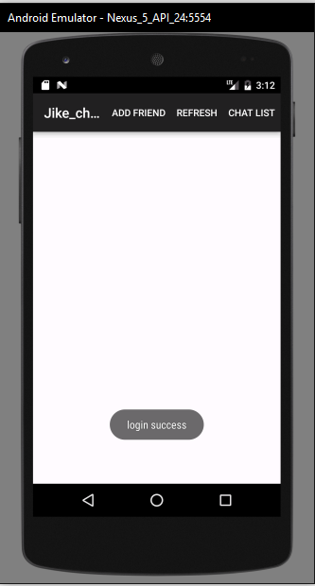

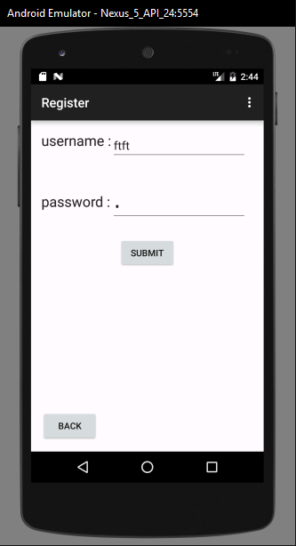  
  
  
  
  
  
  
  
  
  
  
  
  
  
  
  
  
  
  
  
  
  
  
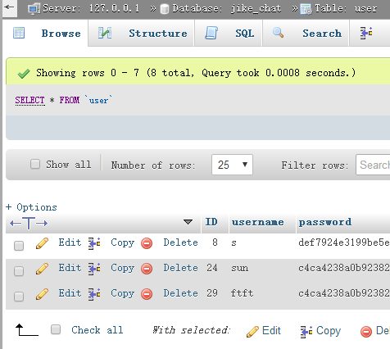

After user input username”ftft” and password”1” then click submit button, the App will automatically use the username and password to login. When user login there will pop up a Toast to inform user that login successfully. From the results shown above, the login activity and register activity works perfectly.The data of user details have been inserted into the database successfully.

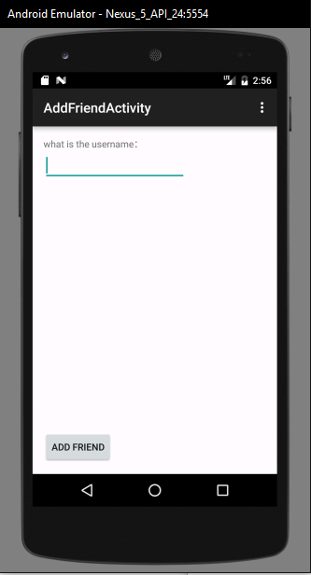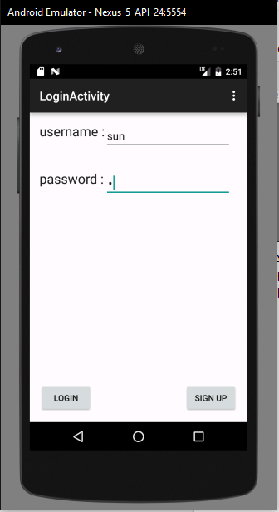  
  
  
  
  
  
  
  
  
  
  
  
  
  
  
  
  
  
  
  
  
  
  
  
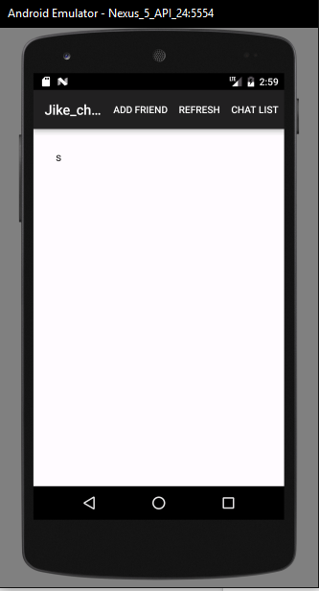

After user successfully login their account,  they can add friend to their friend list. User clicks the “add Friend” button, then it will change to “addFriend” page. The user should input a valid username, after click the “add” button, that been added user appears in the user’s friend list.

System Testing

For our functionality in this iteration,  we can successfully run user registration, user login and add friend functions. For user registration, system will validate the username whether it is exist or not, and then either alert them or insert data to database. Moreover, when user login they must fill in the login information first before they can click ‘Sign In’ button otherwise system will warning them. Furthermore, user can now add friend to their own friends list by searching their friend’s username and click ‘Add Friend’ button.

For our non-functionality in this iteration, usability requirement already achieve user-friendly by using consistency mapping for textfield and button for user easy to use. When the application detected error, it can display warning message for users, for an example, login information insert wrong, will display a ‘login failed’ message to users.

For performance requirement, we haven’t test because it may contain send message and start conversation function for fully testing. In security requirement, we are encrypting user account by using password. And we using POST method in php which can hide the user login details compare to GET method which will show the login details in URL.